MorehGuide – User Guide
Introduction
MorehGuide is an AI-powered assistant designed for Braude Academic College students and lecturers.
The system helps users quickly access academic regulations, procedures, and institutional information using an advanced AI chat interface powered by Gemini AI.
The platform supports role-based access (Student, Lecturer, Admin) and enables secure interaction with official PDF documents uploaded by the administration.

1. Login Page
The Login page allows registered users to enter the system or continue in Guest mode.
Users enter their email and password and click Sign In. New users can select Sign Up to create an account, while guests may choose Continue as Guest for temporary access.
The page also includes a Light/Dark mode toggle for visual preference.
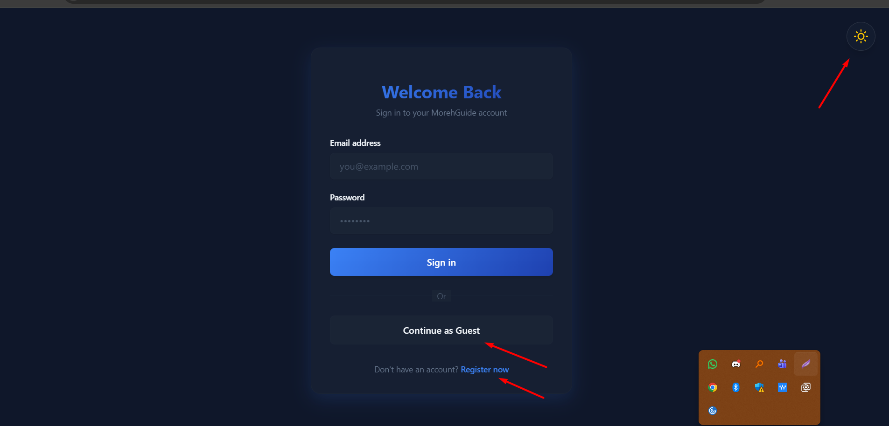
2. Registration Page
New users can create an account through the Registration page by entering their full name, email, and password.
After successful registration, the system redirects the user to the login page to authenticate and continue using the platform.
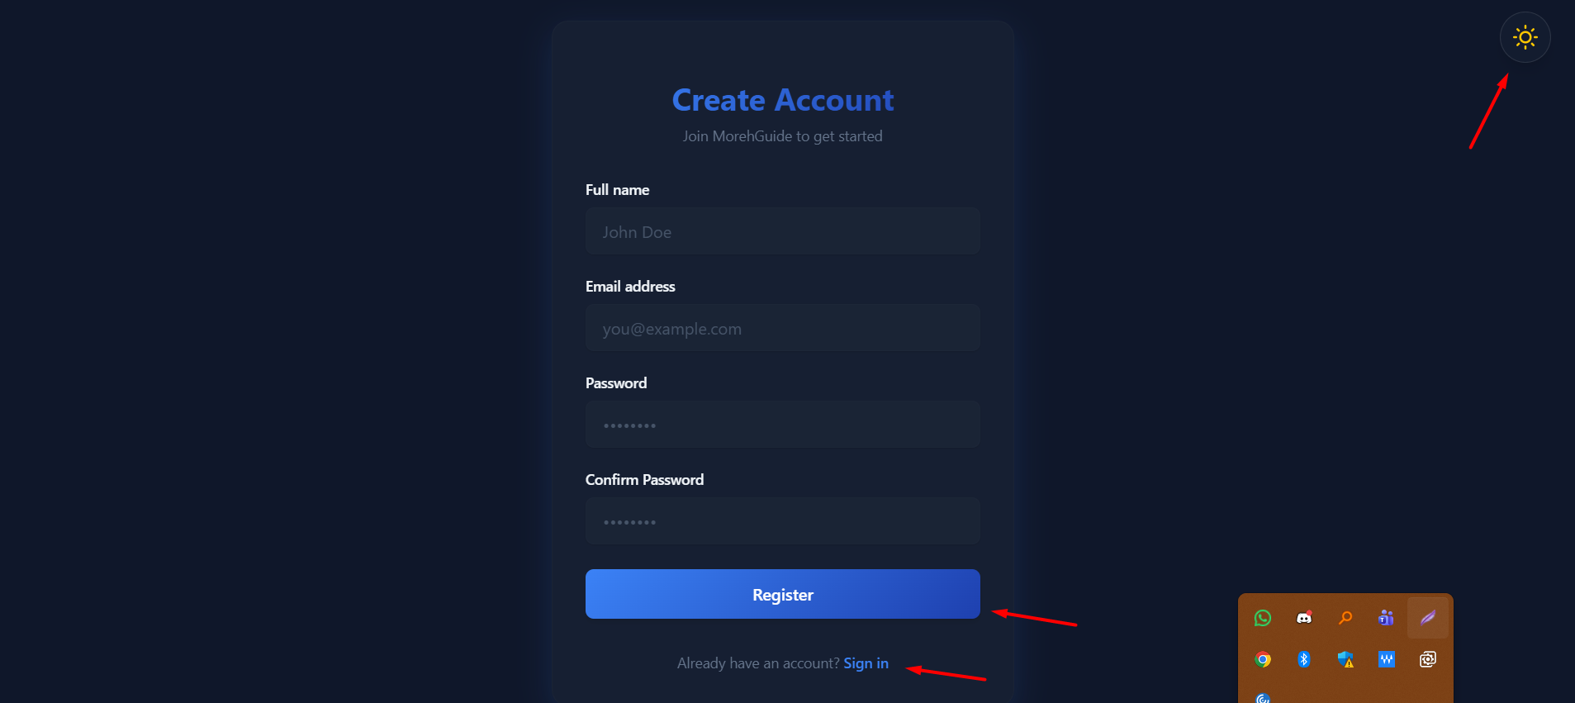
3. Role Selection
After login, users select their role (Student or Lecturer).
The selected role determines which documents and information the AI assistant can access when answering questions.
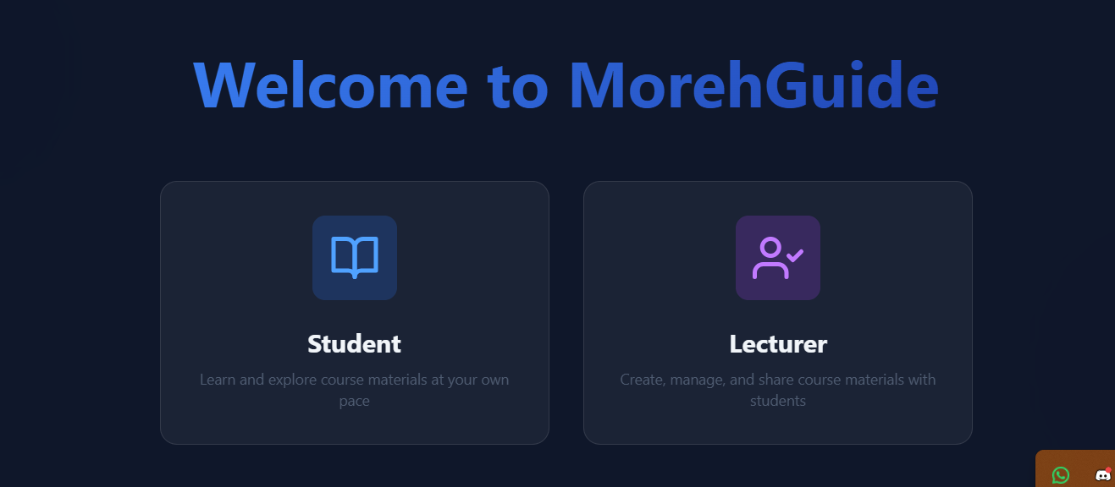
4. Chat Interface (Main Feature)
The Chat interface is the main working area of the system.
Users can ask questions regarding college rules, academic procedures, and institutional information.
The AI assistant processes the request and returns a formatted answer based on authorized documents.
Users can:
- Start a new conversation
- View previous chats
- Continue existing conversations
- Ask follow-up questions
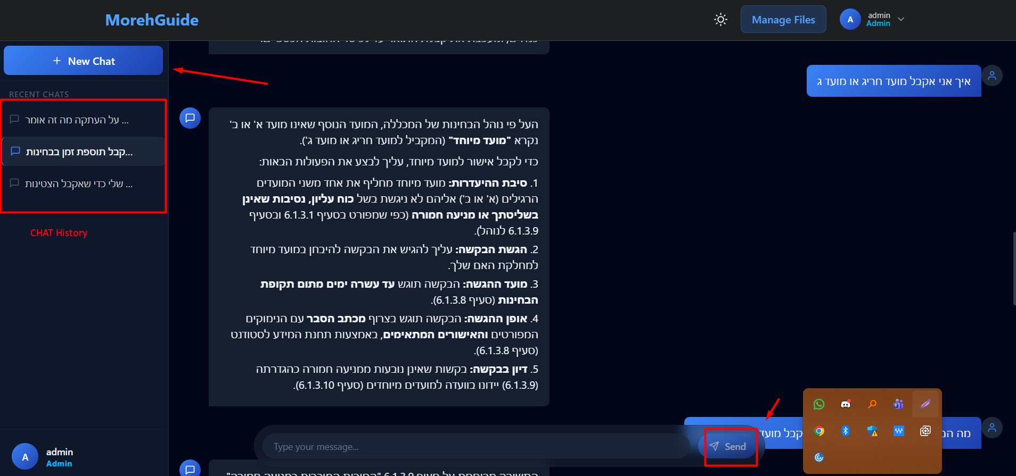
5. Settings Page
The Settings page allows users to manage their profile information such as name, email, and profile picture.
Changes can be saved or discarded using the provided buttons.
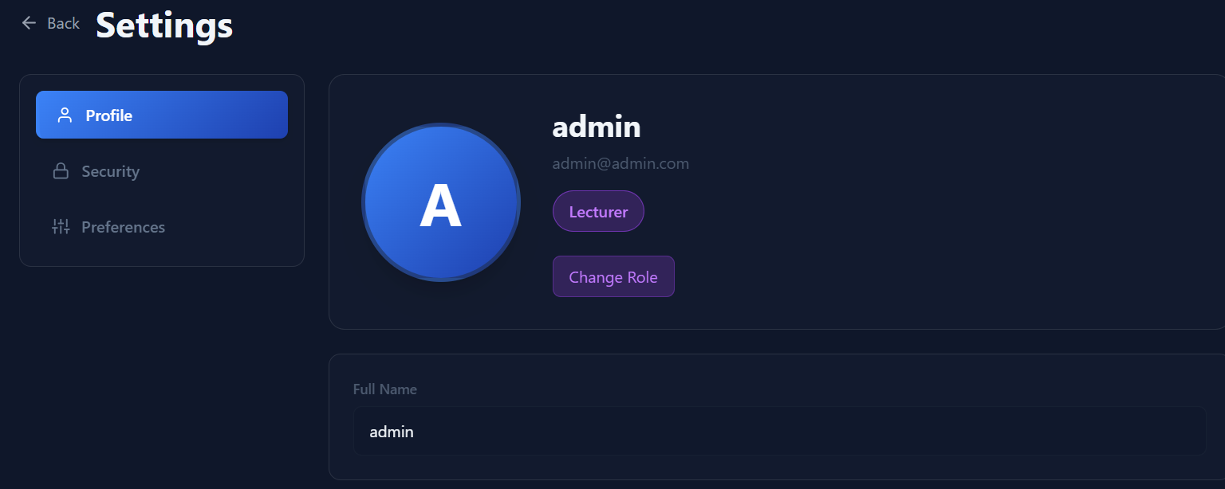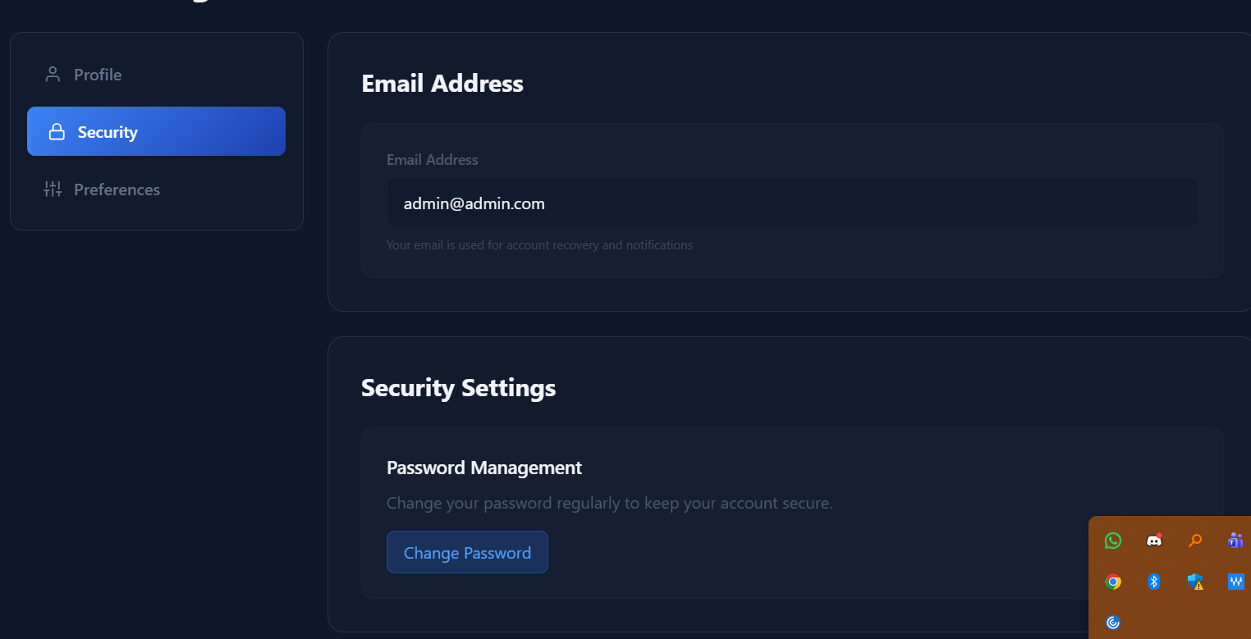
6. Admin Panel (Administrators Only)
Administrators have access to the Files Management Panel, where they can upload, edit, and delete PDF documents that form the knowledge base of the AI assistant.
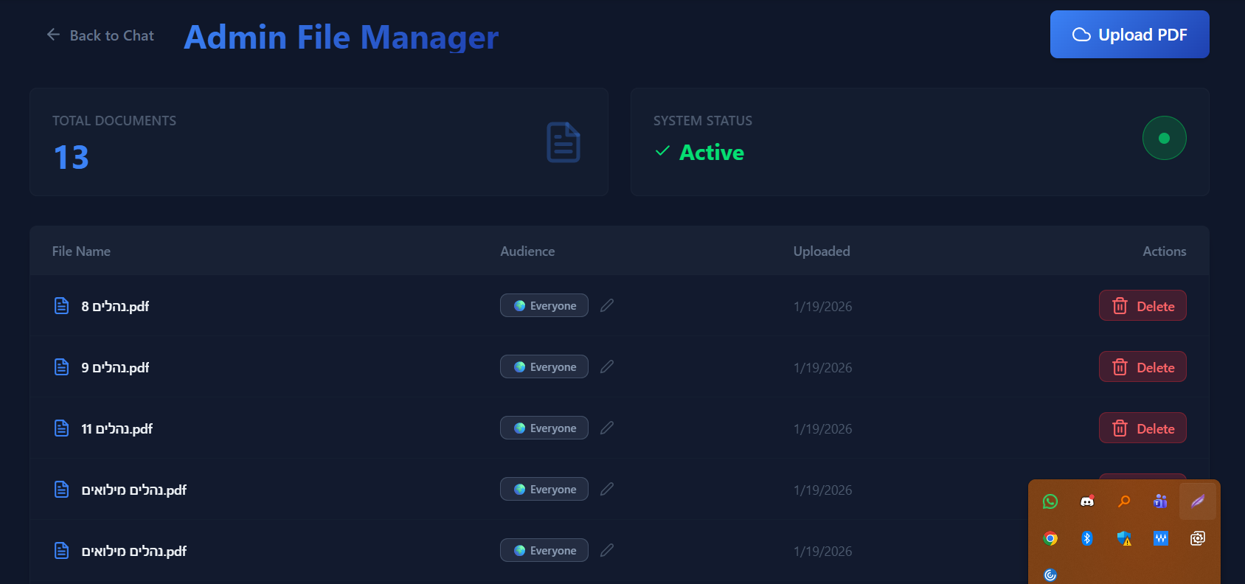
7. Logout
Users can logout from the system using the Logout option located in the top-right user menu.
After logout, the system redirects back to the login page.
